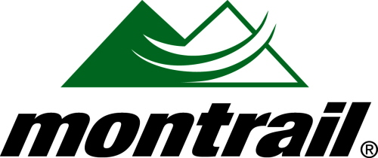

PRESENTS:

“AN HOUR WITH ELLIE GREENWOOD”

Where: Kintec 400 Capilano Road, Unit 9 – Port Moody, BC

When: Wednesday July 7th. Drinks and light snacks @6pm. Ellie @7pm.

Who: Ellie is a member of the Montrail Ultra Running Team, Club Fat Ass and the Vancouver Falcons. Recently she set the World Record for 100km on trail and four weeks later won the Calgary Marathon in record time. Ellie is arguably the heavy favorite to win the IAU World 100k Championship this fall in Gibraltar, Spain.

Ellie will be talking about some of her experiences during these record setting runs as well as taking questions regarding training, nutrition, racing etc.

Prizes: Montrail will be providing some random draw prizes for those in attendance! They will also have a display tent available with all the line up of trail shoes, performance sandals and gear.

Partner: Kintec is proud to partner with Montrail to host this event. Kintec is Montrail Canada’s largest distributor and specializes in performance footwear be it for 100km ultra marathons like Ellie runs or footwear to walk your dog in.

RSVP: Email Ryne Melcher rynemelcher@gmail.com or call 604-800-3338 for more information and if you plan on attending!

